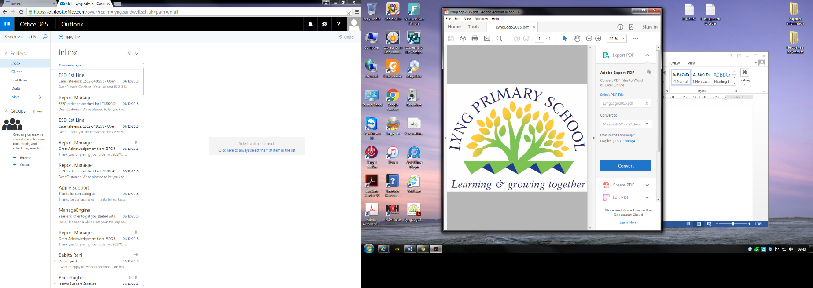

Attendance Policy

Taken from DFE guidance

Working together to improve school attendance and Keeping Children Safe in Education and Working Together to Safeguarding Children

Agreed by Governors: September 2024

Chair of Governors: Date:

Attendance Policy

**Introduction**

We want our children to be the very best they can be at Lyng Primary. We aim for an environment which enables and encourages all members of the community to reach out for excellence. For our children to gain the greatest benefit from their education it is vital that they attend regularly and therefore, your child should be at school, on time, every day the School is open unless the reason for the absence is unavoidable.

**Why Regular Attendance is so important?**

Learning:- Any absence affects the pattern of a child’s schooling and regular absence will seriously affect their learning. Any pupil’s absence disrupts teaching routines and so may affect the learning of others in the same class, it may cause them embarrassment, and it may make sustaining friendships difficult. Ensuring your child’s regular attendance at school is your legal responsibility and permitting absence from school without a good reason, creates an offence in law and may result in prosecution.

Safeguarding:- Your child may be at risk of harm if they do not attend school regularly. Safeguarding the interests of each child is of paramount importance to us. At Lyng Primary, promoting the welfare and life opportunities for your child encompasses:- attendance, behaviour management, health and safety, access to the curriculum and anti- bullying. If a child has a high number of absences the Safeguarding Lead, Mrs Wellings, will be informed and safeguarding procedures will be followed.

**Promoting Good Attendance**

Lyng Primary staff, Pupils and Parents will focus on supporting a pattern of regular attendance by:

* Submit a daily attendance return to the Department of Education, in line with the legal expectations placed on all schools;
* Build strong relationships and work jointly with families;
* Give parents/carers details on attendance in our newsletters;
* Promote the benefits of high attendance;
* Accurately complete admission attendance registers and have effective day to day processes in place to follow-up absence as required by law;
* Celebrate excellent attendance by displaying and reporting individual and class achievements;
* Reward good or improving attendance;
* Report to parents/carers regularly on their child’s attendance and the impact on their progress;
* Contact parents/carers should their child’s attendance fall below the school’s target for attendance.

**Wave 1 – pupils with 100-95% attendance**

**Postcard sent home for good attendance, Termly Popcorn and film for 98%, Class room trophy for 100% attendance, £5 draw weekly for 100% attendance, Teacher encouragement , PSHE, Good attendance benefits**

**Designated staff with responsibility for attendance**

Andrew Fowler – Head Teacher

Sian Wellings – Senior Leader for Attendance/ Designated Safeguarding Lead/Senior Mental Health Lead

Kerry Knight – Attendance officer

Lynn Howard – Chair Of Governors

**The Governing Body**

Improving attendance requires consistent focus and review and an effective whole school approach, with guidance, support and challenge from the Governing Body. It is the responsibility of the Governing Body to:

* Recognise the importance of school attendance and promote it within the school’s ethos and policies.
* Ensure school leaders fulfil expectations and statutory duties.
* Regularly review attendance data, discuss and challenge trends, and help school leaders focus improvements efforts on the individual pupils or cohorts who need it most.
* Ensure school staff receive adequate training on attendance.
* Set high expectations for all leaders, staff, pupils, and parents.
* Recognise that attendance improvement does not happen in isolation and therefore ensuring it is prioritised in wider improvement strategies, such as raising attainment, behaviour, special educational needs and disabilities, wellbeing, and safeguarding.
* Ensure the schools’ attendance management processes are delivered effectively, and that consistent attendance support is provided for pupils who require it most, by prioritising the staff and resources needed. This includes ensuring that the school engages and works effectively with the Local Authority (LA) School Attendance Support Team (SAST) and wider local partners and services.
* Ensure high aspirations are maintained for all pupils, but that processes and support are adapted to the individual needs of particular pupils. This includes those with long-term illnesses, special educational needs and disabilities, pupils with a social worker and pupils from cohorts with historically lower attendance such as those eligible for free school meals.
* Repeatedly evaluate the effectiveness of the school’s processes and improvement efforts, to ensure they are meeting the needs of pupils as experiences and barriers to attendance evolve.

**School Attendance and the Law**

New legislation was passed, The School Attendance (Pupil Registration) (England) Regulations 2024 which introduced a National Framework in England. By law all children of compulsory school age must receive an appropriate full-time education (Education Act 1996).  Parents have a legal duty to ensure their child attends school regularly at the school at which they are registered.

Parents may be recognised differently under education law, than under family law. Section 576 of the Education Act 1996 states that a ‘parent’, in relation to a child or young person, includes any person who is not a parent (from which can be inferred ‘biological parent’) but who has parental responsibility, or who has care of the child.

**Understanding Types of Absence**

Every half-day absence from school has to be classified by the school (not by the parents), as either AUTHORISED or UNAUTHORISED. This is why information about the cause of any absence is always required.

Authorised absences are morning or afternoons when a child is absent for good reason, such as for:

* illness
* a medical/dental appointments which unavoidably falls in school time with proof being submitted
* The death of immediate family member:, Parent, Brother, Sister, Grandparent (requires retrospective evidence)
* In the event of travelling abroad due to immediate family serious/critical illness (required evidence three days on returning)

Unauthorised absences are those absences which the school does not consider reasonable and therefore hasn’t been granted. This type of absence can lead to the Local Authority (LA) using sanctions and/or legal proceedings.

This includes reasons such as: (This list is not exhaustive)

* parents/carers keeping children off school unnecessarily, because they had a late night or for non-infectious illness or injury that would not affect their ability to learn
* truancy
* absences which have never been properly explained
* children who arrive at school too late to get a mark
* shopping trips
* birthday trips
* Day trips
* holidays in term time
* Visit a family member abroad due to illness not deemed critical.
* Further absence (Alleged illness) following a period of absence disclosed on leave of absence form

**Relationships and (RHE) and health education**

Parents **can’t** withdraw their children from relationships or health education (RHE) If children are removed from school this will be an unauthorised absence and may lead to prosecution.

Parents can withdraw their children from sex education, apart from the aspects covered by the science curriculum.

**PE**

Parents **can't** withdraw their children from PE. This includes:

* Swimming in KS1/KS2 is part of the National Curriculum
* Off-site PE activities arranged by the school as part of the curriculum
* Cold weather –a risk assessment to determine whether it's safe enough to carry out PE lessons in cold weather. The risk assessment should identify risks involved and any steps that can be taken to mitigate these

Whilst any child may be off school because they are ill, sometimes they can be reluctant to attend school. Any problems with regular attendance are best sorted out between the school and the parents and the child. If your child is reluctant to attend, it is never better to cover up their absence or to give in to pressure to excuse them from attending. This gives the impression that attendance does not matter and can usually make things worse.

**Persistent Absenteeism (PA)**

A pupil becomes a ‘persistent absentee’ when they miss 10% or more schooling across the school year for whatever reason. This can be authorised and unauthorised. Absence at this level can cause considerable damage to any child’s educational prospects and we need parents fullest support and co-operation to tackle this. We monitor all absence thoroughly. Any case that is seen to have reached the PA mark or is at risk of moving towards that mark is given priority and you will be informed of this immediately. PA pupils are those pupil who drop below 90% and are tracked and monitored carefully. We request to see any parent whose child’s attendance falls below 90%. We will work closely with the LA’s Attendance & Prosecution Officer on matters of PA, or with those at risk of falling into this category.

**Wave 2 – pupils with attendance between 95%—85%**

**Home visit from Welfare Officer, letter from School highlighting concerns with attendance , call from Designated Safeguard Lead (DSL), meeting with DSL and Attendance Officer, offer any family support required, deliver interventions by Attendance Officer with child , letter sent by school to parents /carers, offer Early Help Assessment , support from School Attendance Support Team**

**Religious Education**

Lyng Primary school grants requests in writing from parents to withdraw their child, wholly or partly, from:

Receiving religious education (RE) given in the school in accordance with the school’s basic curriculum

Attendance at religious worship in the school

**Wave 3 - pupils with attendance between 85% - 70%**

**Parents/Carers meeting with Welfare officer, Attendance Officer, Designated safeguarding lead (DSL), Senior Mental Health Lead (SMHL) involvement, Pastoral Team, DSL Home visit, Parent attendance contract, Support from SAST, offer Early Help Assessment. DSL seek advice from LA Sandwell Children's Trust**

**Severely absent**

A pupil who has missed 50% or more schooling is defined by the Government as ‘**severely absent’**. Pupils within this cohort may find it more difficult to be in school or face bigger barriers to their regular attendance and, as such, are likely to need more intensive support.

**Wave 4 - Safeguarding concerns**

**Children whose attendance is below 50 %**

**DSL assessment and referal to Sandwell Children's Trust for Educational Neglect**

Lyng Primary School, and all who work to support children and their families to improve attendance, will continuously review if progress is being made. If it is felt that sufficient progress isn’t being made, a review of the concern will be compiled. Leading on from these concerns, a referral to Sandwell Children’s Trust will be completed as a result of ‘Educational Neglect’. (*Working Together to Improve School Attendance, KCSIE and Working together to safeguard children*)

**Absence Procedures**

* If your child is absent you must **contact us as soon as possible on the first day of absence**. You must telephone the school office or call into school and report to reception 0121 553 1480. Before 9am when register closes (Dojo **must not** be used to report your child’s absence)
* Contact the school on every further day of absence, again before *9am*
* We will log the reason for absence on our School Information Management System (SIMS).
* If your child is absent and you have not contacted the school, we will telephone or text you on the first day of absence. Again reasons will be logged.
* If your child has been off school for 3 days, school staff will conduct a home visit to complete a wellbeing check.
* If we are unable to make contact with parents by telephone, Parents have not contacted school, we will telephone emergency contact numbers, send letters home. If school is unable to make contact after exhausting all types of contact DSL will contact police to report a child missing and a referral to Sandwell Children’s Trust
* Ensure that your child returns to school as soon as possible and provide any medical evidence, if requested, to support the absence. Medical evidence may be requested where your child is having multiple periods of absence which are reported as being due to medical reasons. When determining whether a child is too ill to attend school, both parents and school staff can consider the advice contained within the NHS and Sandwell Council Guidance on School Absence and Childhood Illness

To help us all to focus on supporting pupils whose attendance is falling below expectations, we have implemented ‘waves’ of support as follows:

**Local Authority attendance support services**

The Schools Attendance Support Service works strategically by offering support to schools, to reduce persistent absence and improve overall attendance.

Parents are expected to work with the school and local authority to address any attendance concerns. Parents should proactively engage with the support offered, aiming to resolve any problems together. This is nearly always successful. If difficulties cannot be resolved in this way, the school may consider more formal support and/or refer the child to the Local Authority. If attendance does not improve, legal action may be taken in the form of a Penalty Notice (see Annex B for the Sandwell Code of Conduct) or prosecution in the Magistrates Court.

**Lateness**

Poor punctuality is not acceptable. If your child misses the start of the day, they miss key time with the class teacher, miss work and miss out on vital information and news for the day. Late arriving pupils disrupt lessons and this can be embarrassing for the child, which can also encourage further absence.

**How we manage lateness:**

The school day starting times are listed below and we expect your child to be in class at these times:

|  |  |
| --- | --- |
| **Year Group** | **Start time** |
| Rec | 8.30am |
| Y1 | 8.30am |
| Y2 | 8.30am |
| Y3 | 8.40am |
| Y4 | 8.40am |
| Y5 | 8.40am |
| Y6 | 8.40am |

Poor punctuality is not acceptable and can sometimes lead to irregular school attendance patterns. Good time-keeping is a vital life skill which will help children as they progress through their school life and out into the wider world.

Pupils who arrive late disrupt lessons and, if a child misses the start of the day, they can feel unsettled and embarrassed and risk missing vital work and important messages from their class teacher.

**The times of the start and close of the school day for all pupils at X School are:**

Gates open: 8.25am

Registration closes: 9.15am

End of the school day: 3pm KS1 and Early Years

3.10pm KS2

**How we manage lateness:**

* The school day starts at ***8.30am for Early Years, KS1 and 8.40am for KS2*** when children can begin to come into school;
* Registers are taken at ***8.35am for Early Years, KS1 and 8.45am for KS2***
* Children arriving after ***the times*** are required to come into school via the school office. If accompanied by a parent/carer they must sign them in late in the school reception and provide a reason for their lateness, which is recorded on the SIM’s system At ***9.15am*** the registers will be closed. In accordance with the Regulations, if your child arrives after that time, they will receive a mark that shows them to be on site – ‘U’, but this will **not** count as a present mark and it will mean that they have an unauthorised absence;
* The school may contact parents/carers regarding punctuality concerns;

Unauthorised lateness could result in the school referring to the Local Authority for sanctions and/or legal proceedings. If your child has a persistent lateness record, you may be asked to meet with Mrs Wellings/Mrs Knight, but you can approach us at any time if you are having difficulties getting your child to school on time. We expect parents and staff to encourage good punctuality by being good role models to our children.

**School Attendance and the Law**

New legislation was passed, The School Attendance (Pupil Registration) (England) Regulations 2024 which introduced a National Framework in England. By law all children of compulsory school age must receive an appropriate full-time education (Education Act 1996).  Parents have a legal duty to ensure their child attends school regularly at the school at which they are registered.

Parents may be recognised differently under education law, than under family law. Section 576 of the Education Act 1996 states that a ‘parent’, in relation to a child or young person, includes any person who is not a parent (from which can be inferred ‘biological parent’) but who has parental responsibility, or who has care of the child.

A person typically has care of a child or young person if they are the person with whom the child lives, either full or part time and who looks after the child, irrespective of what their biological or legal relationship is with the child.

**National Framework for Penalty Notices**

There is now a single consistent national threshold for when a penalty notice must be considered by all schools in England, of 10 sessions (usually equivalent to 5 school days) of unauthorised absence within a rolling 10 school week period. The 10 sessions of absence do not have to be consecutive and can be made up of a combination of any type of unauthorised absence (G, O and/or U coded within the school’s registers). The 10 school week period can span different terms, school years or education settings.

Sanctions may include issuing each parent (for each child) with a Penalty Notice for £160, reduced to £80 if paid within 21 days (for the first offence). A second Penalty Notice issued within a three year period will result in a fine of £160 per parent, per child. If a third offence is committed the matter may be referred to the local authority for consideration of prosecution via the Magistrates Court. If prosecution is instigated for irregular school attendance, each parent may receive a fine of up to £2500 and/or up to 3 months in prison. If a parent is found guilty in court, they will receive a criminal conviction.

See Annex D for the Sandwell Code of Conduct.

**There is no entitlement in law for pupils to take time off during the term to go on holiday or other absence for the purpose of leisure or recreation, or to take part in protest activity in school hours.**  In addition, the Supreme Court has ruled that the definition of regular school attendance is “in accordance with the rules prescribed by the school.”

The School Attendance (Pupil Registration) (England) Regulations 2024 set out the statutory requirements for schools.   All references to family holidays and extended leave have been removed. The amendments specify that headteachers may not grant any leave of absence during term time unless there are "exceptional circumstances" and they do not have any discretion to authorise up to ten days of absence each academic year.

It is a rule of this school that a leave of absence shall not be granted in term time unless there are reasons considered to be exceptional by the headteacher, irrespective of the child’s overall attendance.  Only the headteacher or his/her designate (not the local authority) may authorise such a request and all applications for a leave of absence must be made in writing, in advance, on the prescribed form provided by the school. The school will usually consider that the parent who has made the application is therefore allowing the leave of absence, and also that all parents who are on the holiday are allowing the leave. Where a parent removes a child after their application for leave was refused or where no application was made to the school, the absence will be recorded as unauthorised. It is likely that penalty notices will be requested, in line with the National Framework and Sandwell Code of Conduct, in respect of each parent believed to have allowed the absence.

**Contacting Other Setting/Schools**

As part of our procedures, our staff will contact other settings/schools where our pupils’ siblings attend to complete checks, and to make sure that we are doing all we can to remove barriers for attendance.

**Pupils with Medical Conditions**

Those children with medical Conditions or Special Educational Needs are entitled to education like any other child. Therefore, procedures will be the same. However, staff will be mindful of the barriers these children face and will put additional support in place where necessary to help them access full time education.

**Attendance targets**

The minimum level of attendance for each pupil is 95%. The school will keep parents updated regularly about pupil progress and how your child’s attendance compares to that target.

**Children attending alternative provision or managed move**

For a reason in which a child is to attend an alternative provision, for example, a Pupil Referral Unit or a child attending another educational setting; (although dual registered) the child will continue to be registered at Lyng Primary School. Therefore, the Attendance Officer will communicate daily with the setting to make sure the child is in attendance. If there are any concerns, the Safeguarding Leads at Lyng Primary School and the alternative educational setting will make contact. Safeguarding procedures will be implemented.

**Child on a Part Time TimeTable**

When a decision made by the Head Teacher, for a child to be placed on a part time timetable, the parent/carer will be notified during a meeting with Head Teacher and a member of the Pastoral Team. The child will continue to be on roll at Lyng Primary School and external agencies will be notified. The child will be seen by a member of the Pastoral Team at the family home. The Pastoral Team will make sure that the child’s wellbeing is closely monitored and that the child accesses the curriculum.

Communication between School and home will continue and safeguarding procedures will be in place. The class teacher will also provide learning for the child while they are at home. Equipment will be provided by school for the child’s education to continue during the part time timetable arrangement.

A Part time timetable is a short-term intervention and steps will be made to allow the child back into school full time, with external agency support.

**Parenting contracts**

A parenting contract is a formal written agreement between a parent and either the school or LA to address irregular attendance at school or alternative provision. A contract is not legally binding but allows a more formal route to secure engagement, with support, where a voluntary early help plan has not worked or is not deemed appropriate. A parenting contract is not a punitive tool it is intended to provide support and offer an alternative to prosecution. Parents cannot be compelled to enter a contract, and they cannot be agreed in a parent’s absence.

**Education Supervision Order (ESO)**

Where all interventions have been put in place and an Early Help Assessment has not been successful, an ESO for formal legal intervention will be a discussed and maybe applied for.

ESOs are made through the Family or High Court, rather than Magistrates Court. They give the LA a formal role in advising, helping and directing the pupil and parent(s) to ensure the pupil receives an efficient, full-time, suitable education. For the duration of the ESO, the parent’s duties to secure the child’s education and regular attendance, are superseded by a duty to comply with any directions given by the LA under the ESO.

If it is decided to progress with an ESO, the LA should notify parents in writing of the intention to consider an ESO and set up a meeting to discuss with the parent (including the pupil if they are old enough to understand). Following the conversation, the LA should make its decision and inform the parent and pupil of whether the case will be taken forward to court or not. Where the decision is to proceed, this can be combined with the service of an application notice

**Children who have a Social Worker or Family Support Worker**

Any child who has a Social Worker or a Family Support Worker and are absent from school, the school will inform the Social Worker or Family Support Worker that the child is absent. The school’s Safeguarding Lead or Welfare Officer may conduct a home visit.

**Children in Care**

Lyng Primary School will work closely with a child’s Social Worker and Virtual Heads to make sure that children in care who are registered at Lyng Primary School, attend school regularly and that interventions are put into place to make sure that children have consistency.

**Multi Agency Working**

Where attendance for family or pupils are complex, the school’s Attendance Team will work with external agencies, such as the LA, and any other services who can support the family to address concerns. A ‘Team Around the Family’ will work together to remove barriers and set targets for families to improve the child’s attendance.

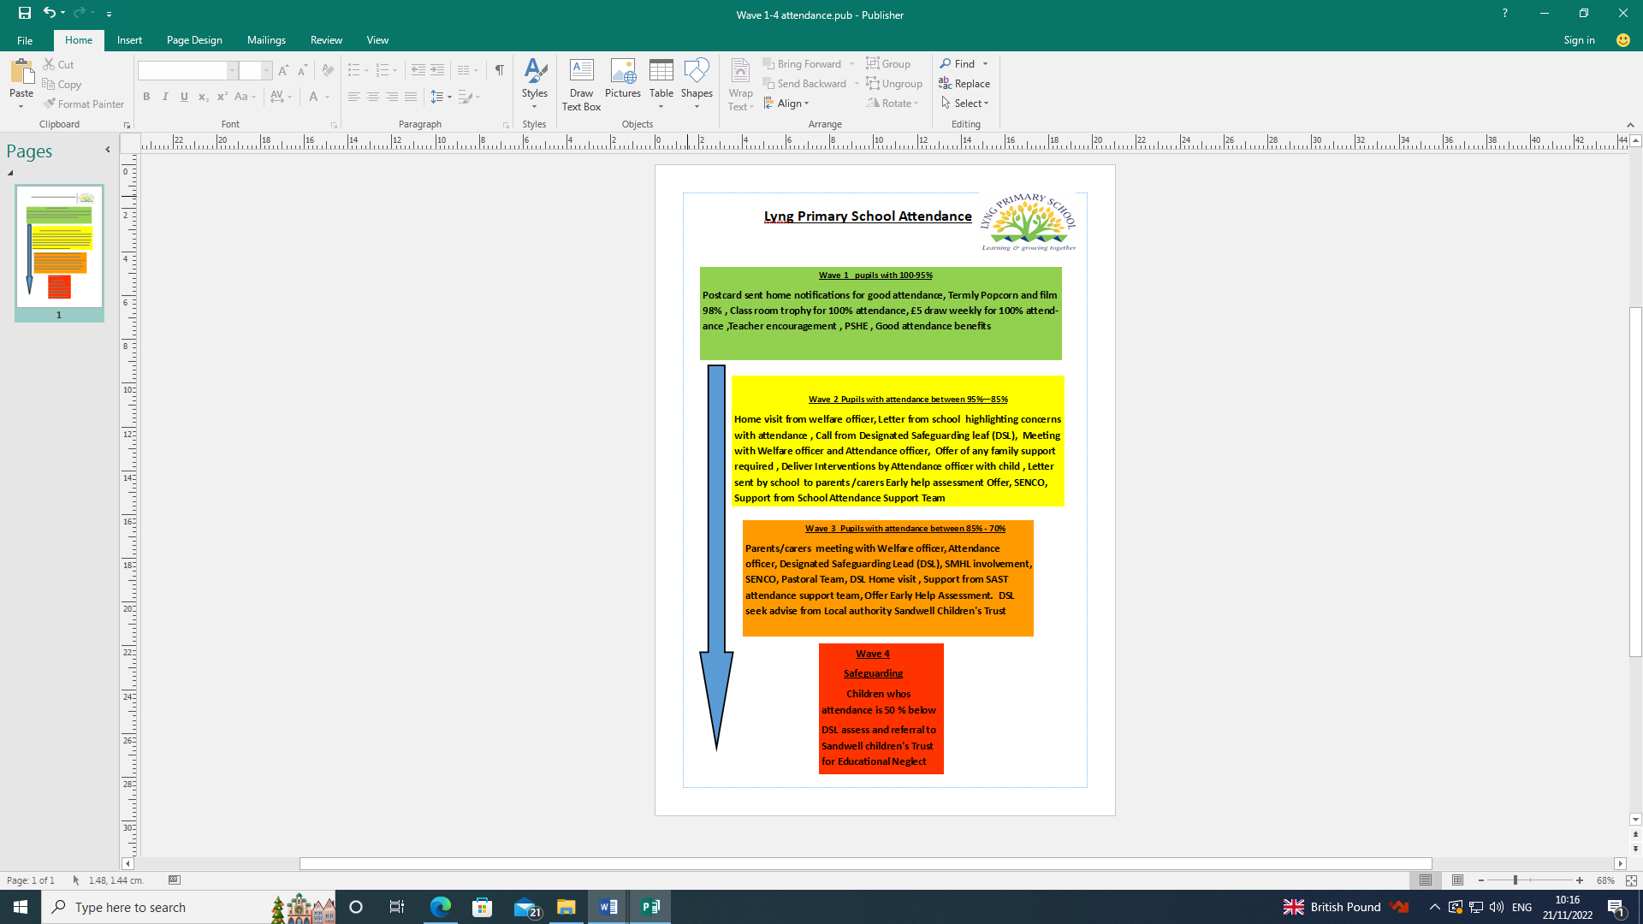 Appendix A



Headteacher: Mr A Fowler

Horton Street, West Bromwich, West Midlands, B70 7SQ.

Telephone: 0121 553 1480 - Email: [lyng.admin@lyng.sandwell.sch.uk](mailto:lyng.admin@lyng.sandwell.sch.uk) - Website: www.lyng.sandwell.sch.uk

Parent/carers address

**School Attendance Concern – Pupil Name:** XXXXXXXXXXXXXXXXXXXXXXXXXXXXXXXXXX

Our routine monitoring of the school register has identified a decline in your child’s attendance which is causing us concern. **Your child has had amount of xxxxxx days absent from school so far since September**. Poor attendance will significantly impact on your child’s education, friendships and potential to achieve.

A meeting has now been arranged to discuss the above matter.

The meeting will be held at: **Lyng primary School**

on:

at:

The aim of this meeting is to establish reasons for absence and offer advice and support if necessary.

It is therefore very important that you attend this meeting. If for any reason you are unable to attend, please contact the (school office/attendance officer) on the following telephone number: 0121 553 1480

Failure to hear from you, or your non- attendance at the above meeting, may result in a referral to the Attendance & Prosecution Service.

**Please note that the Education Act 1996 makes it the parents/carers responsibility to ensure that their child regularly attends the school to which they are on roll. Failure to do so may result in legal action against you** – Please see overleaf for important information regarding this.

Yours sincerely,

Xxxxxxxxxxxx

xxxxxxxxxxxxxxxxxxxxxxx

**Legal Action**

**Information for Parents**

**Section 23(1) Anti-Social Behaviour Act 2007:**

Penalty Notices may be issued to the parent of pupils who have unauthorised absence from school. The amount of the penalty is £60.

* If this is not paid within 21 days, the amount rises to £120.
* If not paid within 28 days, the Local Authority may prosecute under Section 444(1) unless it comes to our attention that the penalty notice had been issued in error.

**Section 444(1) Education Act 1996:**

“If you are the parent of a child of compulsory school age who fails to attend school regularly, you are guilty of an offence.”

* The court can fine each parent up to £1,000 per child, order payment of the prosecution costs and/or impose a Parenting Order.

**Section 444(1A) Education Act 1996:**

“If in the above circumstances you, the parent, know that your child is failing to attend regularly at the school and fail without reasonable justification to cause him/her to attend, you are guilty of an offence.”

* The court can fine you up to £2,500 per child, order payment of the prosecution costs, impose a Parenting Order and/or sentence you to a period of imprisonment of up to 3 months.

**Please note that:**

* Penalties and prosecutions are in respect of each parent for each child.
* “Parent” includes any person who is not a parent but who has parental responsibility for the child or who has care of him/her.

**These prosecutions are criminal proceedings and could result in you having a criminal record.**

**How does your child compare?**

|  |  |  |  |
| --- | --- | --- | --- |
| **Attendance during one school year** | **Equals this number of days absent** | **Which is approximately this many weeks absent** | **Which means this number of lessons missed** |
| **90%** | **19 days** | **4 weeks** | **100 lessons** |
| **80%** | **38 days** | **8 weeks** | **200 lessons** |
| **70%** | **57 days** | **11.5 weeks** | **290 lessons** |

**Frequent absence can add up to a considerable amount of lost learning and can seriously disadvantage your child in adult life.**

**Annex C: DfE guidance Summary table of responsibilities for school attendance. From 19th August 2024**

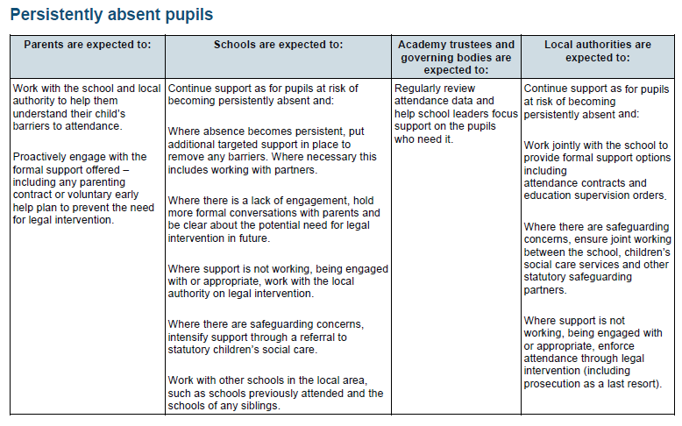<https://assets.publishing.service.gov.uk/media/65e8ae343649a2001aed63aa/Summary_table_of_responsibilities_for_school_attendance__applies_from_19_August_2024_.pdf>

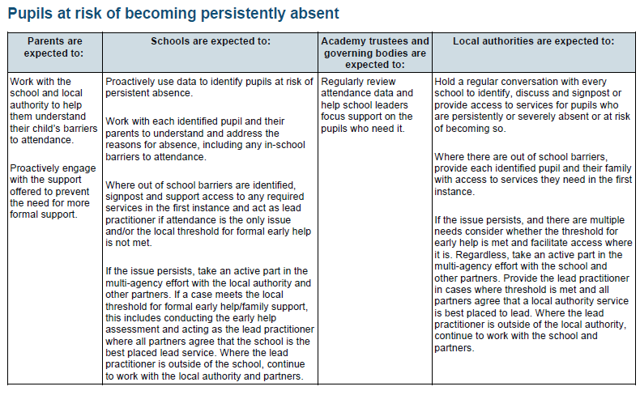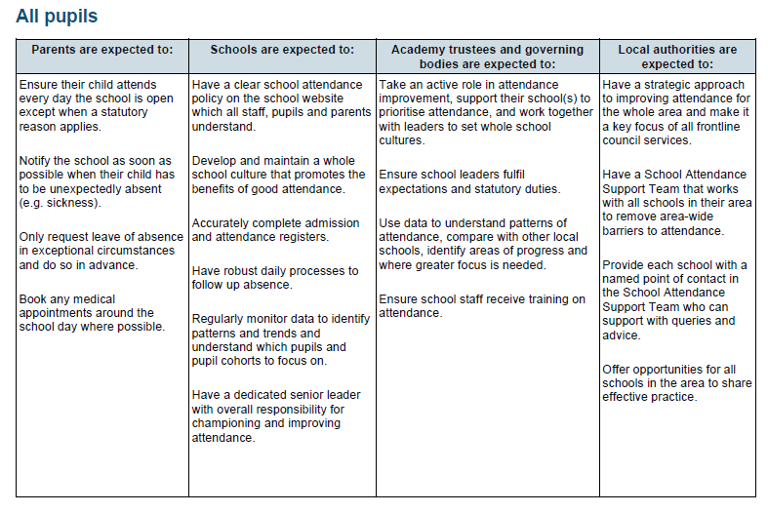

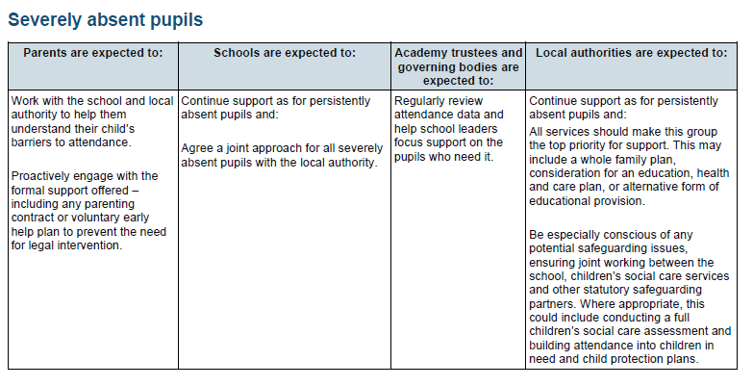

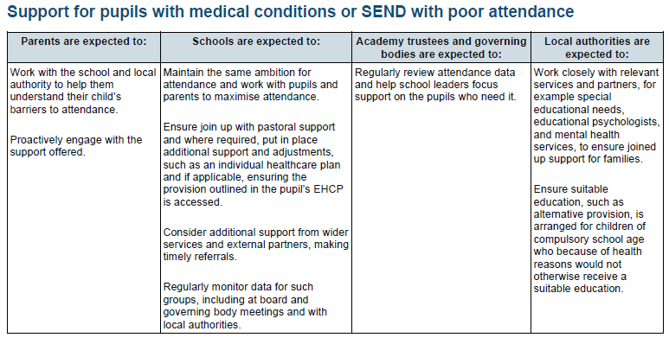

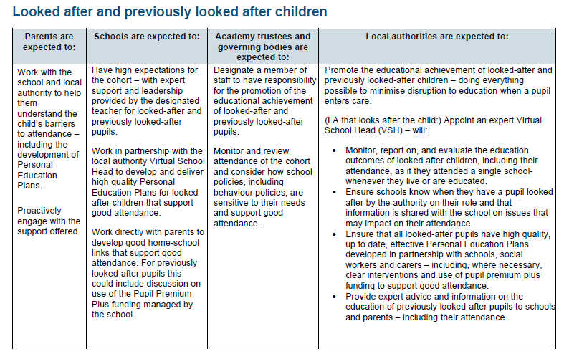

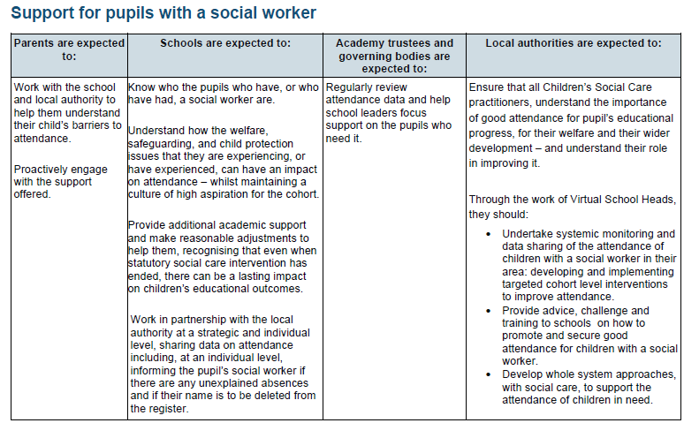

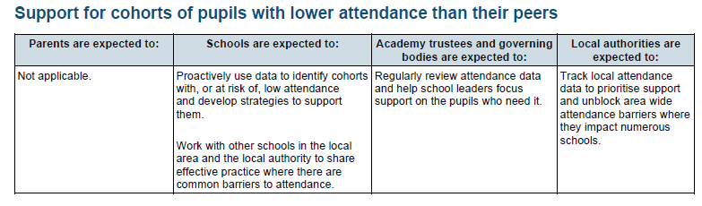

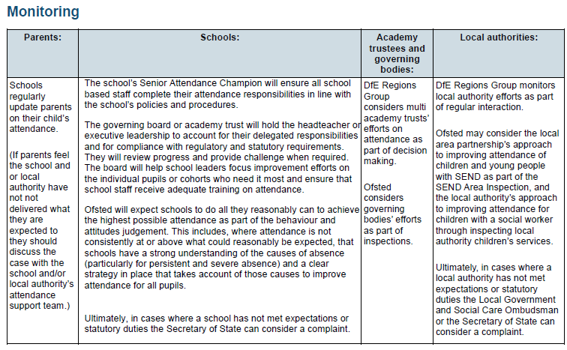

**Annex D**

**Schools Attendance Support Service – updated June 2024**

**PENALTY NOTICE CODE OF CONDUCT**

1. The purpose of this local code of conduct is to ensure that penalty notices for school absence are issued in a manner that is fair and consistent across Sandwell. The code sets out the arrangements for administering penalty notices in Sandwell and must be adhered to by anyone issuing a penalty notice for school absence in this area. The code complies with relevant regulations and the Department for Education’s national framework for penalty notices as set out in the ‘[Working together to improve school attendance](https://www.gov.uk/government/publications/working-together-to-improve-school-attendance)’ guidance.

**Consultation**

1. This code has been drawn up in consultation with the headteachers and governing bodies of state funded school and the local police force.

**Legal Basis**

1. The regular, punctual attendance of pupils at the school where they are registered is both a legal requirement and essential for students to maximise the educational opportunities available to them.
2. Penalty notices may be issued to a parent as an alternative to prosecution for irregular school attendance under s444 of the Education Act 1996. They can only be issued in relation to pupils of compulsory school age in maintained schools, pupil referral units, academy schools, alternative education provision academies, and certain off-site places as set out in section 444A(1)(b).
3. The Education (Penalty Notices) (England) Regulations 2007 (as amended) set out how penalty notices for school absence must be used.
4. A penalty notice can only be issued by an authorised officer, that is, a headteacher or a deputy or assistant head authorised by them, an authorised local authority officer or a police constable. In Sandwell, penalty notices will be issued by authorised local authority officers at the request of a Head Teacher, someone authorised by them, or at the request of a police officer.
5. The national framework for penalty notices is published in statutory guidance ‘Working together to improve school attendance’. It provides further national guidance on the operation of penalty notice schemes for school absence in England.
6. Schools and the local authority will decide which parent(s) to involve in attendance legal intervention according to the circumstances of each individual case.
7. A parent includes any person who is not a parent but who has parental responsibility for the child or who has care of the child, as set out in section 576 of the Education Act 1996. Penalty notices will usually be issued to the parent or parents with day-to-day responsibility for the pupil’s attendance or the parent or parents who have allowed the absence, regardless of which parent has applied for a leave of absence.

**Rationale**

1. Research published by the Department for Education in May 2022 found pupils with higher attainment at KS2 and KS4 had lower levels of absence over the key stage compared to those with lower attainment.
   * Pupils who did not achieve the expected standard in reading, writing and maths in 2019 had an overall absence rate of 4.7% over the key stage, compared with 3.5% among pupils who achieved the expected standard and 2.7% among those who achieved the higher standard.
   * Pupils who did not achieve grade 9 to 4 in English and maths GCSEs in 2019 had an overall absence rate of 8.8% over the key stage, compared with 5.2% among pupils who achieved a grade 4 and 3.7% among pupils who achieved grade 9 to 5 in both English and maths.
2. For the most vulnerable pupils, regular attendance is also an important protective factor and often the best opportunity for needs to be identified and support provided.
3. Where difficulties arise with school attendance, professionals should take a ‘support first’ approach in line with the DfE’s ‘Working together to improve school attendance’ guidance, only resorting to legal enforcement when necessary. The aim is that the need for legal enforcement is reduced by taking a supportive approach to tackle the barriers to attendance and intervening early before absence becomes entrenched.
4. The national framework for penalty notices is based on the principles that penalty notices should only be used in cases where:

* support is not appropriate (for example, where a term time holiday has been taken) or where support has been provided and not engaged with or not worked, and
* they are the most appropriate tool to change parental behaviour and improve attendance for that family.

**Circumstances where a penalty notice for absence may be appropriate**

National Threshold of 10 sessions in 10 school weeks

1. The national threshold is met when a pupil has been recorded as absent for 10 sessions (usually equivalent to 5 school days) within 10 school weeks, with one of, or a combination of the following codes:

* Code G: the pupil is absent without leave for the purpose of a holiday
* Code N: the circumstances of the pupil’s absence have not yet been established
* Code O: none of the other rows of Table 3 in Regulation 10(3) of the School Attendance (Pupil Registration) (England) Regulations 2024 applies)
* Code U: the pupil attended after the taking of the register ended but before the end of the session, where no other code applies)

1. A school week means any week (Monday to Sunday) in which there is at least one school session. The 10 school-week period may span different terms or school years – for example: 2 sessions of unauthorised absence in the summer term in one school year and a further 8 within the autumn term of the next school year.
2. When a school becomes aware that the national threshold has been met, they must consider whether a penalty notice can and should be issued or not and where appropriate, a referral made to the Council’s Schools Attendance Support Service.

Truancy Sweep

1. During or following a truancy sweep, a penalty notice may be issued in relation to the absence and the local authority will retain the discretion to issue a penalty notice before the national threshold is met.

Excluded pupils

1. Where parents allow their child to be present in a public place during school hours without reasonable justification during the first 5 days of a fixed period or permanent exclusion.

Repeated penalty notices

1. If repeated penalty notices are being issued and they are not achieving the desired change in behaviour, they may not be most appropriate tool. The national framework for penalty notices sets out that a maximum of 2 penalty notices per child, per parent can be issued within a rolling 3-year period.

**Key considerations prior to the issue of a penalty notice for school absence**

1. The following considerations will be made before issuing a penalty notice to ensure consistency of approach.
2. Where children do not have current attendance concerns and where support is not appropriate (for example, where the parent takes the child on an unauthorised leave of absence in term time), consideration will be given to:
   * + - Is a penalty notice the best available tool to improve attendance and change parental behaviour or would one of the other legal interventions be more appropriate?
       - Is issuing a penalty notice in this case appropriate after considering any obligations under the Equality Act 2010
       - Is it in the public interest to issue a penalty notice in this case given the local authority would be accepting responsibility for any resulting prosecution for the original offence in cases of non-payment?
3. In cases where support is appropriate to address historic / ongoing irregular attendance concerns, consideration will be given to:

* Has sufficient support been provided? Support is defined as any activity intended to improve the pupil’s attendance and should be tailored to the individual circumstances relating to the pupils absence. Where appropriate schools should work closely with the appropriate partner agencies.
* Is a penalty notice the best tool available likely to improve attendance and change parental behaviour for this family or would one of the other legal interventions be more appropriate?
  + - * Is issuing a penalty notice in this case appropriate after considering any obligations under the Equality Act 2010
      * Is it in the public interest to issue a penalty notice in this case given the local authority would be accepting responsibility for any resulting prosecution for the original offence in cases of non-payment?

1. If the answer to the above questions is ‘yes’, then a penalty notice (or a notice to improve in cases where support is appropriate) will usually be issued, providing it is in the public interest to do so.

**Notice to improve**

1. A notice to improve is a final opportunity for a parent to engage in support and improve attendance before a penalty notice is issued. If the national threshold has been met and support is appropriate but offers of support have not been engaged with by the parent or have not worked, a notice to improve should usually be sent to give parents a final chance to engage in support.
2. A notice to improve may be issued by either the school or the local authority.
3. The school and/or the local authority will determine whether a notice to improve is appropriate or not. It may not be appropriate where it is not expected to have any impact on a parent’s behaviour (e.g. the parent has already received one for a similar offence).
4. A notice to improve must state the timescales for the improvement period which should be no more than 20 school days. School will monitor attendance during the improvement period following a notice to improve being issued.
5. Where there has been sufficient and/or sustained improvement of attendance, it is not expected that further legal intervention will be necessary at that stage. If there has been no or insufficient improvement of attendance, further consideration will be given to the issue of a penalty notice.

**Penalty notices issued for absences from 2024/25 school year onwards**

1. For issuing penalty notices for absences occurring after the start of the 2024/25 school year, the “proceeding 3-year period” means the period of 3 years ending with the date on which the penalty notice is issued.
2. Where no penalty notice has been issued to the parent in respect of an individual child in the preceding 3-year period, the amount of the penalty is £80 where the amount is paid within the period of 21 days beginning with the date on which the notice is issued, rising to £160 between days 21 and 28.
3. Where a penalty notice has been issued to the parent in respect of an individual child in the preceding 3-year period, the amount of the penalty is £160 and is payable within 28 days.
4. Where 2 previous penalty notices have been issued and the national threshold is met for a third time (or subsequent times) within the rolling 3-year period, a penalty notice will not be issued. Instead, an alternative strategy or legal intervention will be used having considered any previous penalty notices which were unpaid and any subsequent prosecution of offences.
5. For the purpose of the escalation process, previous penalty notices include those not paid (including where prosecution was taken forward if the parent pleaded or was found guilty) but not those which were

* withdrawn
* issued in respect of an excluded pupil
* issued in respect of an absence prior to the start of the 2024/25 school year

**Withdrawing a penalty notice**

1. A penalty notice may be withdrawn if

* it ought not to have been issued or issued to the person named as the recipient;
* the notice contains material errors;
* the issuer did not comply with this code of conduct; or
* after the expiry of the last date for payment the penalty notice is unpaid and the local authority has neither instituted proceedings for the offence to which the notice relates nor is contemplating such proceedings.

1. Where a penalty notice has been withdrawn, notice of the withdrawal shall be given to the parent and any amount paid by way of penalty in pursuance of that notice shall be repaid to the person who paid it.
2. No proceedings shall be continued or instituted against the parent for the offence about which the withdrawn notice was issued or for an offence under S444 of the Education Act 1996 arising out of the same circumstances, except where it was withdrawn due to a material error and a further penalty notice was issued at the same time as withdrawal of the original notice.

**Payment of penalty notices**

1. The arrangements for the paying penalties will be detailed on the penalty notice. The local authority will retain any revenue to cover enforcement and administration of justice costs as detailed in legislation.

**There is no statutory right of appeal to the local authority against the issue of a penalty notice. The local authority issue penalty notices at the request of the Headteacher/Principal. Any dispute/challenge about penalty notices must be referred to Headteacher/Principal.**

**How authorised officers will work together**

1. Authorised officers should work together to ensure that penalty notices are used when likely to be effective and change behaviour.
2. On receipt of the relevant referral form(s) from the school or the police, the local authority will continue to issue penalty notices on their behalf.
3. An authorised local authority officer will decide whether proportionate support has been provided, and whether that support has worked or not.
4. The local authority will inform the school if, and why, a referral is not being progressed. It will also inform the school about whether penalty notices are paid, withdrawn or prosecuted for non-payment. They will do this half termly by way of email.
5. Where pupils move between local authority areas and it is necessary to establish whether a penalty notice has previously been issued, Sandwell can be contacted by email at crossborder_pn@sandwell.gov.uk
6. Where pupils attend school within Sandwell but live in a different local authority area, Sandwell will accept referrals from Sandwell schools for children on their roll.

**Annex D**

**Legistlation and support links for Parent/Carers**

<https://www.gov.uk/government/publications/working-together-to-improve-school-attendance>

<https://www.legislation.gov.uk/uksi/2024/210>

[How to improve your child’s school attendance and where to get support   – The Education Hub (blog.gov.uk)](https://educationhub.blog.gov.uk/2024/01/03/improving-school-attendance/)

[Support & advice for parents | NSPCC](https://www.nspcc.org.uk/keeping-children-safe/support-for-parents/)

[School Anxiety and Refusal | Parent Guide to Support | YoungMinds](https://www.youngminds.org.uk/parent/parents-a-z-mental-health-guide/school-anxiety-and-refusal/)